ContentGen – AI-Powered Blog Management Platform

TEAM ID: SWTID-2026-7353 TEAM SIZE: 5

TEAM LEADER: | MADHUMITHA V
TEAM MEMBER: | KOWSALYA S
TEAM MEMBER: | LOGIDHAA R
TEAM MEMBER: | MARIYAMMAL L
TEAM MEMBER: | MATHANGI M

Description
ContentGen is a modular backend platform designed for blog publishing, content organization, and AI-assisted writing. It uses Node.js and Express.js to expose REST endpoints, while MongoDB stores application records through Mongoose. The architecture separates routing, validation, business rules, and persistence so that each area can be maintained independently.
The platform supports article creation, category organization, comment handling, authentication, and optional AI generation or summarization. JSON Web Tokens protect authenticated routes, while password values are stored using secure hashing rather than plain text.
The main goal is to reduce repetitive content-management work while keeping final editorial control with the user. AI output can be reviewed and edited before publication, and the API can be consumed by a separate web or mobile interface.

AI-Assisted Content Pipeline
Topic / Prompt
AI Service
Draft / Summary
Figure 1. Fresh illustration of the content-generation pipeline.

Core Objectives
- Provide a consistent REST API for blog operations.
- Store users, posts, comments, and categories in MongoDB.
- Apply authentication and role checks to protected routes.
- Offer AI-assisted generation and summarization as optional services.

Scenario-Based Case Study

Background
Meena is a student content editor who maintains technical articles for a small learning portal. She receives posts from several contributors and needs a simple way to review drafts, arrange them under categories, and keep reader comments connected to the correct article.

Problem
- Drafts arrive in different formats and are difficult to track consistently.
- Contributors need different levels of access to the same application.
- Manual categorization makes searching older articles slower.
- Comment review is mixed with normal content work, creating unnecessary effort.
- The team wants AI assistance for first drafts without automatically publishing generated material.

Solution
The proposed BlogNest service centralizes these activities behind authenticated API routes. Role-aware middleware decides which operations a user can perform. Content services manage draft and publishing states, while MongoDB provides persistent storage. An AI service can be called when an author requests a draft or short summary.

Usage
- Author: submits drafts, edits permitted articles, and requests AI assistance.
- Editor: reviews submissions, adjusts categories, and prepares approved posts.
- Administrator: manages accounts, permissions, and system-level records.
- Reader: views public articles and contributes comments.

Outcome
The workflow becomes easier to monitor because each action is represented by an API request and stored against identifiable records. Validation reduces malformed data, authorization limits protected operations, and the separation between AI assistance and publication keeps final editorial control with the user.

1. Software Requirements
- Operating System: Windows 10/11, macOS, or a current Linux distribution.
- Node.js: Version 18 or later is suitable for the application runtime.
- npm: Used to install packages and manage project scripts.
- Express.js: Handles HTTP routes, middleware, and server responses.
- MongoDB: Stores structured documents for users, posts, comments, and categories.
- Mongoose: Provides schemas, validation, and database interaction from Node.js.
- Postman or Thunder Client: Useful for sending API requests and inspecting JSON responses.
- Visual Studio Code: Recommended editor for organizing the project files.

2. Hardware Requirements
- Processor: Intel Core i5 / AMD Ryzen 5 class processor or equivalent.
- Memory: 8 GB RAM as a practical minimum for local development.
- Storage: At least 2 GB of free workspace for the project, packages, logs, and local tools.
- Network: A stable connection is useful for cloud MongoDB and AI-service access.

Development Environment
The application is designed as a cross-platform Node.js project. The same source structure can be used on Windows, macOS, or Linux when the required runtime and packages are available.

Development Setup Sequence
1
Create
Project
2
Initialize
npm
3
Add
Folders
4
Run
Server
Figure 2. Development environment preparation sequence.

EPIC 1: Project Architecture
The backend follows a layered request-processing approach. A client sends an HTTP request to an Express route, middleware validates the request and user identity, service modules apply business rules, and Mongoose communicates with MongoDB. AI-related requests can branch into a separate service before the response is returned.
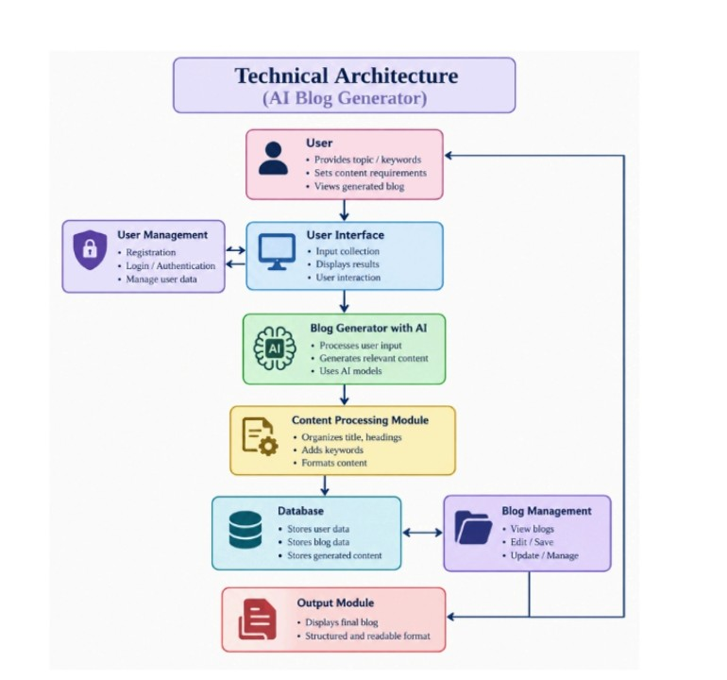

Architecture Components
- Client / API Tool: Sends HTTP requests and receives JSON responses.
- Express Gateway: Registers routes, parses request bodies, handles common middleware, and producesresponses.
- Authentication Middleware: Reads the bearer token and verifies the user's identity.
- Authorization Layer: Checks whether the authenticated role can use a protected operation.
- Service Layer: Contains reusable rules for posts, comments, categories, and AI requests.
- Data Layer: Uses Mongoose models to validate and persist application records.
- AI Integration: Sends selected prompts to an AI provider and returns generated or summarized text.

Layered Backend Request Flow
Client
/Postman
Express
API
Auth &
Services
Mongoose
ODM
MongoDB
Figure 3. Layered request flow for the new document.

Entity-Relationship Model
The data model uses separate collections for users, posts, and comments. References between collections identify who created a post and which post owns a comment. This avoids storing every piece of information inside a single large document.
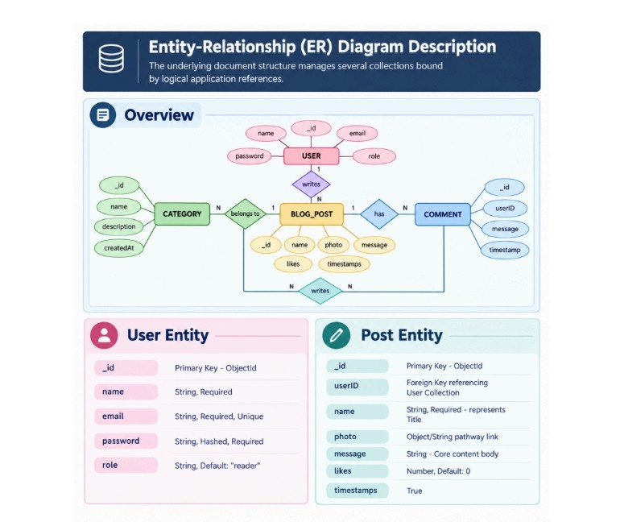

1. User Entity
- _id – unique MongoDB ObjectId.
- name – display name of the account.
- email – unique contact/login identifier.
- passwordHash – protected password value.
- role – permission profile such as admin, editor, author, or reader.

2. Post Entity
- _id – unique post identifier.
- authorId – reference to the user who created the article.
- title – article heading.
- content – main article text.
- category – classification used for filtering.
- status – draft, review, scheduled, or published.
- createdAt / updatedAt – record timestamps.

3. Comment Entity
- _id – unique comment identifier.
- postId – reference to the related post.
- userId – reference to the commenter.
- message – submitted comment text.
- status – pending, approved, or rejected.

Entity Relationship View
USER
_id • name • role
POST
_id • title • body
COMMENT
_id • text • postId
1
: N
1
: N
Figure 4. Simplified relationship map.

Key Structural Mappings
- User → Post: one account can create many posts.
- User → Comment: one account may submit comments on multiple posts.
- Post → Comment: one post can contain many associated comments.

Key Features
- Role-Based Route Protection: protected endpoints verify the account role before continuing.
- Blog CRUD Operations: create, read, update, and delete functions are exposed through structuredroutes.
- Category and Tag Organization: metadata supports filtering and easier content discovery.
- Comment Moderation: comments can move through review states before appearing publicly.
- Input Validation: schemas reject missing or incorrectly typed fields.
- Request Sanitization: unexpected input is filtered before database operations.
- AI Draft Generation: a topic can be converted into an editable article draft.
- AI Summarization: long content can be reduced into a concise abstract for previews.

Roles and Responsibilities
- Administrator: controls users, permissions, moderation, and system configuration.
- Editor: reviews drafts, maintains categories, and prepares content for publication.
- Author: creates and updates permitted posts and can request AI assistance.
- Reader: accesses published material and can submit comments.

User Flow
A normal user journey begins with registration or login. After authentication, the server issues a token that can be attached to later requests. Public readers can retrieve published content, while authors and editors access additional operations according to their roles.
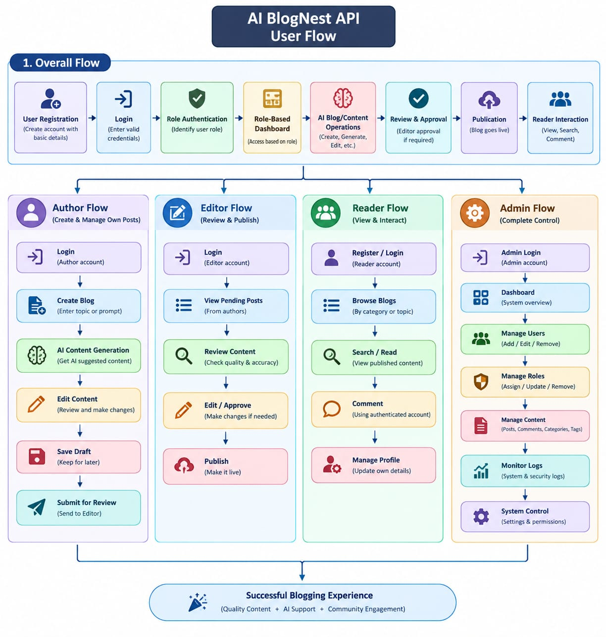

Typical Flow
- 1. Register an account with the required user fields.
- 2. Log in and receive an authentication token.
- 3. Request the blog list or a specific article.
- 4. If permitted, create or update an article.
- 5. Optionally request AI-generated content or a summary.
- 6. Submit comments and allow moderation rules to process them.

Security Checks
- Validate request body fields before processing.
- Verify the JWT signature and token expiry.
- Check role permissions for administrative or editorial routes.
- Hash passwords instead of storing plain text values.
- Return controlled errors without exposing sensitive server details.

API Testing Journey
REGISTER
POST /users
LOGIN
POST /login
CREATE
POST /blogs
GET
/blogs
Figure 5. Example user/API journey.

MVC Architecture Pattern
The backend can be organized around the Model-View-Controller idea to keep data definitions, application logic, and external responses separate. Because this project is a headless API, the View responsibility is represented by JSON responses rather than traditional HTML templates.

Model Layer – Data Blueprint
Mongoose schemas define field types, required values, default states, and validation rules. Models provide the methods used to read or write MongoDB documents.

Controller Layer – Execution Logic
Controllers receive validated request data, call the required service or model operation, and prepare the final response. They should remain focused on request coordination instead of holding every business rule.

View / API Layer – Response Interface
The client-facing layer returns JSON objects, status codes, and error messages. A separate frontend can consume the same API without changing the underlying database structure.

MVC Responsibility Separation
MODEL
Data + Schema
CONTROLLER
Business Logic
VIEW/API
Response Layer
Figure 6. MVC responsibility separation.

EPIC 2: Project Setup and Configuration

Creating the Project Folder
- Create a main folder using the chosen project name.
- Open the folder in Visual Studio Code.
- Create a Server directory for the backend source.
- Open the Server directory in the integrated terminal.

Server Initialization
Run the following command in the Server directory:
npm init -y
Create the initial server file:
server.js

Recommended folders
- models – Mongoose schemas and database models.
- controllers – request-processing functions.
- routes – endpoint definitions.
- middleware – authentication, authorization, and validation.
- services – reusable business and AI operations.
A clear folder structure makes it easier to locate errors and extend the project later. Keeping route definitions separate from database models also reduces unnecessary coupling.

EPIC 3: Backend Development

Server.js
The server entry file creates the Express application, registers middleware, mounts routes, and starts the listening process. A simple setup can include JSON parsing, CORS configuration, and a central error handler.

Example structure
const express = require('express'); const app = express();
app.use(express.json()); app.use('/api/users', userRoutes); app.use('/api/blogs', blogRoutes); app.listen(PORT);

App / Route Organization
Routes define the public API paths and connect them to controller functions. A blog router may expose endpoints for listing posts, reading one post, creating a post, and updating an existing record. Controller Responsibility
- Read incoming parameters and body data.
- Call the appropriate service or model.
- Return a clear status code and JSON response.
- Pass unexpected errors to the centralized error handler.
Request
Validation
Database
Figure 7. Backend request-processing chain.

EPIC 4: Database Configuration

MongoDB Connection
The backend should establish a database connection before handling operations that depend on stored records. Mongoose provides the connection method and maps JavaScript objects to MongoDB documents.

Package Installation
Run the following command inside the project directory:
npm install mongoose

Connection Strategy
- Keep the MongoDB connection string in an environment variable instead of placing credentialsdirectly in source files.
- Connect once when the server starts and handle connection errors clearly.
- Use Mongoose schemas to describe the expected document structure.
- Add timestamps where creation and modification history is useful.
Example environment entry
MONGODB_URI=your_mongodb_connection_string

Example model fields
const userSchema = new mongoose.Schema({ name: { type: String, required: true }, email: { type: String, required: true, unique: true }, role: { type: String, default: 'reader' }
}, { timestamps: true });
This approach keeps connection details outside the application logic while allowing the model layer to enforce basic data rules.

EPIC 5: Project Execution
Before testing the endpoints, install the required packages and start the backend. Postman or Thunder Client can then be used to send requests manually.
Start the Application npm start

API Testing User Registration
Send a POST request to the registration endpoint with a name, email, password, and role if the API permits role selection. A successful request should return a confirmation and/or the newly created user identifier.
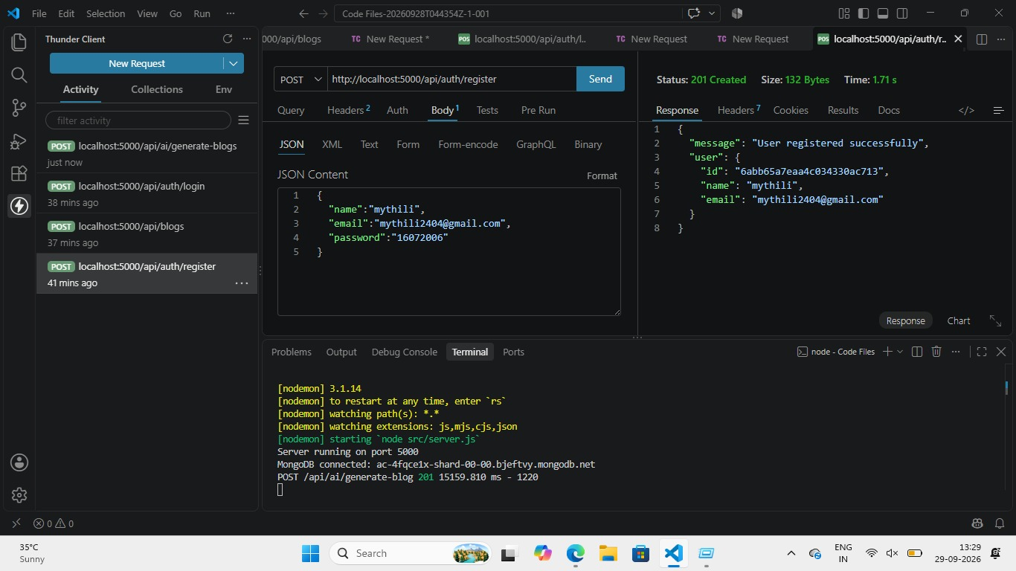

User Login
Send the login credentials to the authentication endpoint. The server verifies the password and returns a token when the credentials are valid. The token is then used in the Authorization header for protected requests.
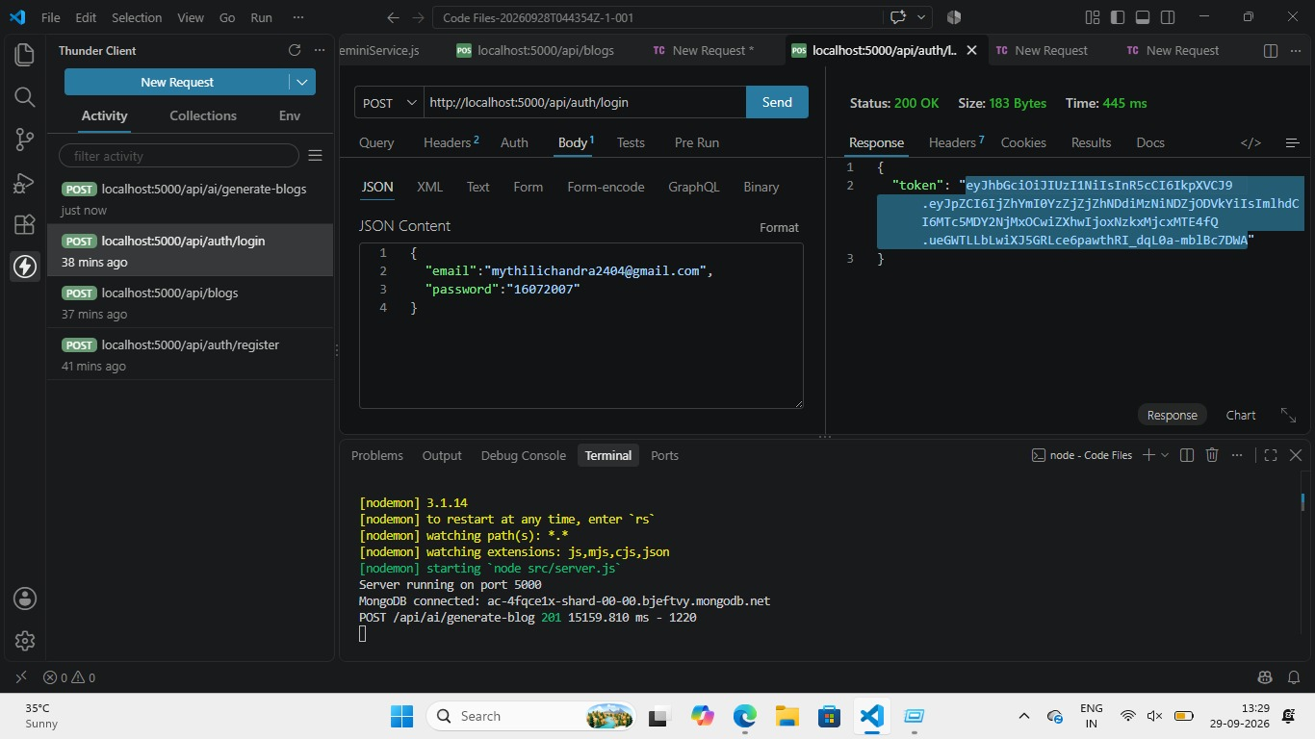

Create Blog
An authenticated author can submit a title, content, and category. The controller validates the fields and stores the resulting document in MongoDB.
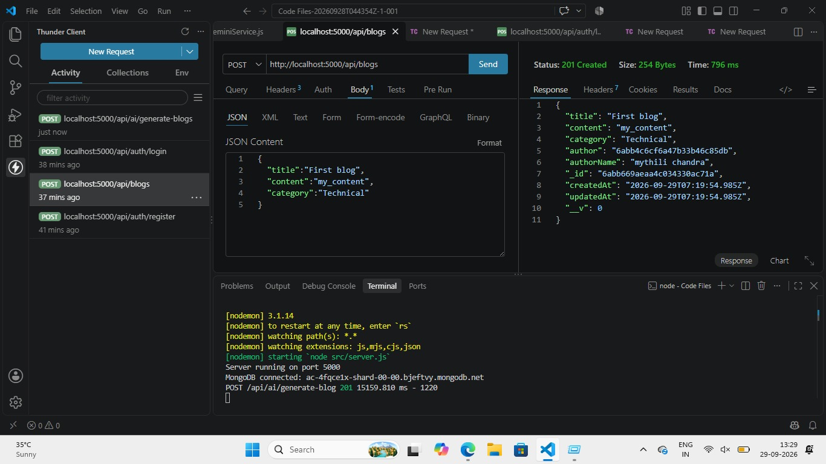

API Testing Journey
REGISTER
POST /users
LOGIN
POST /login
CREATE
POST /blogs
GET
/blogs
Figure 8. Fresh API testing sequence.

Fetch Blogs
A GET request can return published blog records. Query parameters may be added for category, author, keyword, or page number when the backend supports filtering and pagination.
Example request
GET /api/blogs?category=technical&page;=1

Expected Response
The response can contain an array of blog objects together with optional metadata such as the current page, total records, or available categories. Returning consistent JSON makes the endpoint easier for frontend applications to consume.
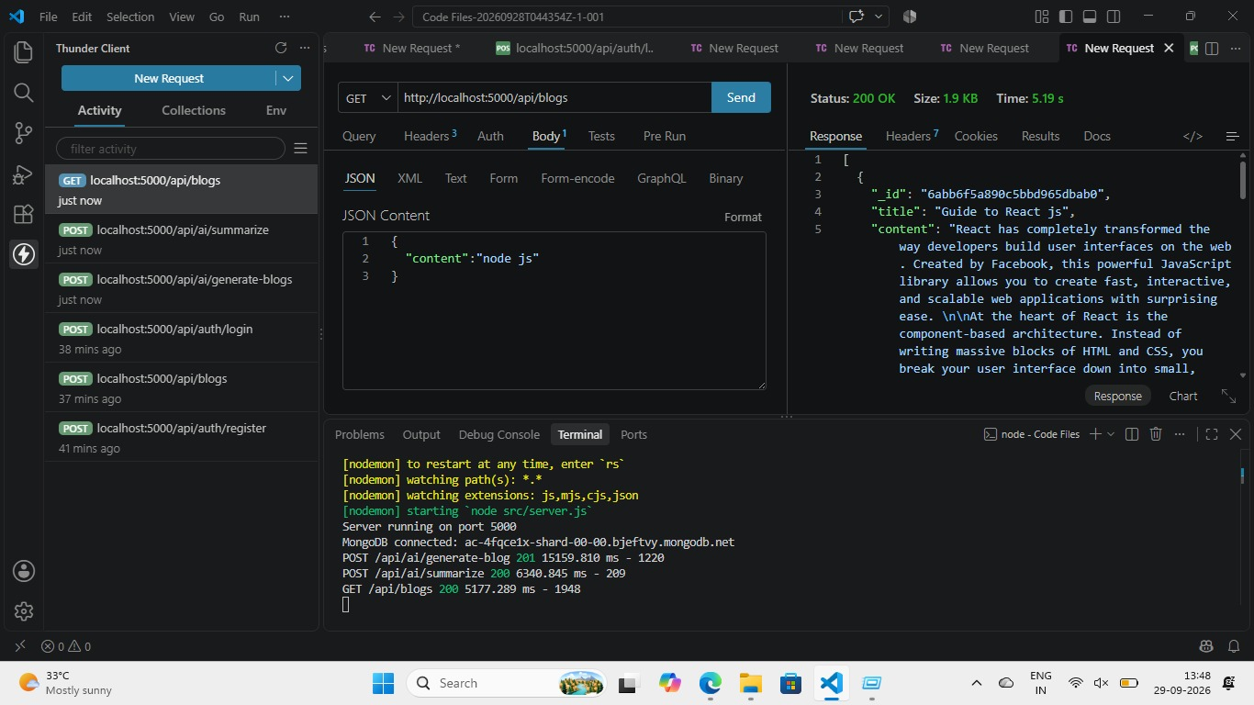

Generate AI Blogs
The AI generation endpoint accepts a topic or short prompt and sends it to the configured AI service. The returned draft should be treated as editable content. The application can save the generated result only after the user chooses to keep it.

Example flow
Topic → Validation → AI Service → Draft → User Review → Save
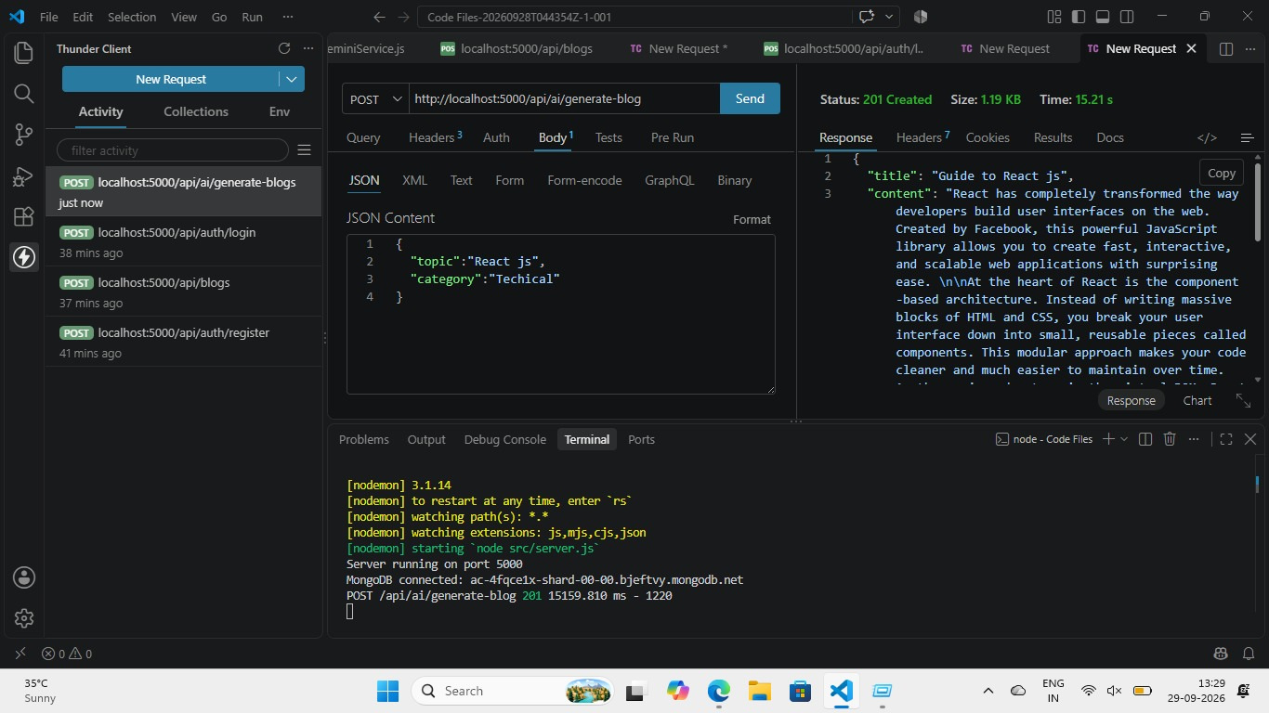
Figure 9. AI generation workflow.

Summarize Blogs
The summarization feature accepts an existing article and requests a shorter representation. A useful implementation can return a compact abstract suitable for cards, previews, or search results.
Example flow
Article Content → Prompt Builder → AI Model → Summary → API Response

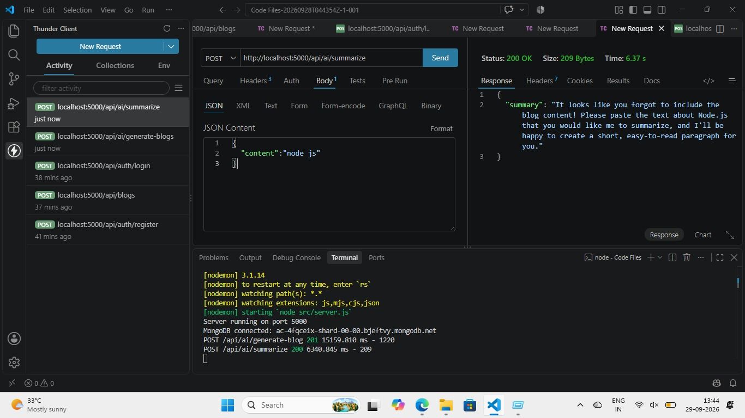

Practical Considerations
- Limit the amount of text sent to the AI service when the provider has input constraints.
- Validate that the article body is present before requesting a summary.
- Return a clear error when the AI service is unavailable.
- Keep generated output separate from the original article so the source content is not accidentallyoverwritten.

